<https://docs.vmware.com/en/VMware-vSphere/6.7/com.vmware.vsphere.vsan-monitoring.doc/GUID-7799D2D7-2513-4372-92EA-4A1FB510E012.html>

***************************

Disable vSAN at host boot.

Reboot the ESXi host.   
During the pre-boot splash screen, press SHIFT+O to modify the boot options.   
In the resulting screen, move to the end of the boot line.   
To disable vSAN kernel module, add a space at the end of the boot line and then add the following line :  
  
jumpstart.disable=vsan,lsom,plog,virsto,cmmds,,   
  
Press the enter key to resume boot.

********************************************

Command to check the Running Task of hosts:

*vim-cmd vimsvc/task_list*

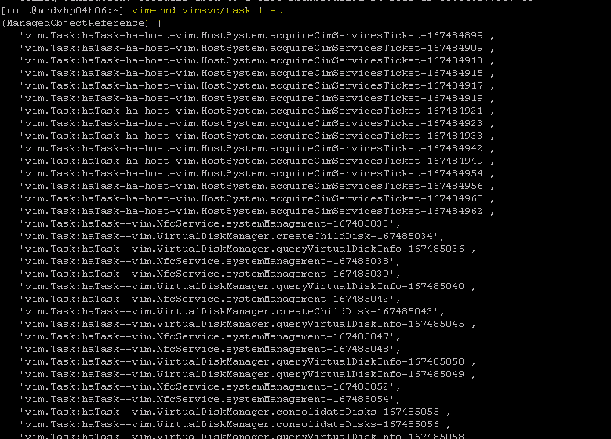

Command to get Host Decom Status:

*cmmds-tool find -f json -t NODE_DECOM_STATE |python -m json.tool|grep -i decomstate*

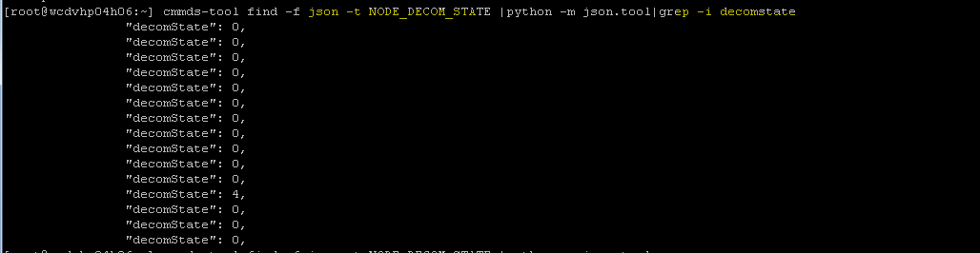

Command to get More Decom details of Hosts.

*cmmds-tool find -f json -t NODE_DECOM_STATE |python -m json.tool*

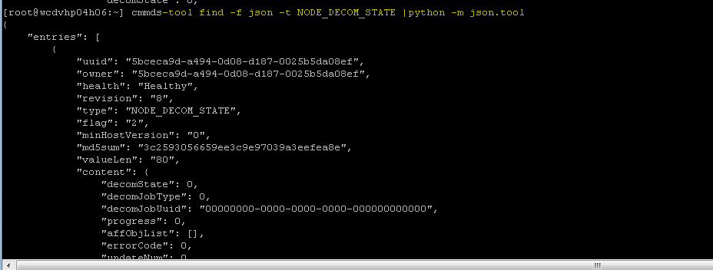

Command to cancel the Host vSAN maintenance task:

*Esxcli vsan maintenance cancel*

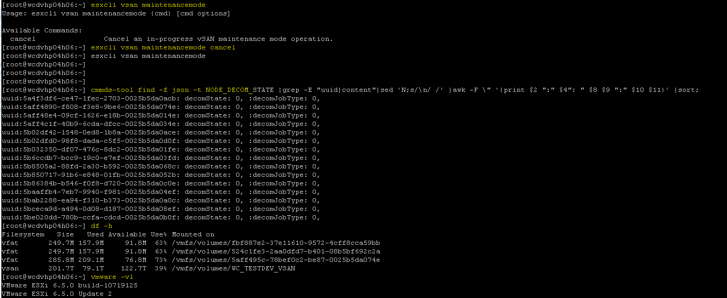

*Command to get the Sorted Size of the Disk:*

*cmmds-tool find -t HOSTNAME -f json | egrep "uuid|hostname" | sed -e 's/\"content\"://g' | awk '{print $2}' | sed -e 's/[\",\},\,]//g' | xargs -n 2 | while read hostuuid hostname; do cmmds-tool find -f json -t DISK -o $hostuuid | egrep "uuid|content" | sed -e 's/\"content\":|\\"uuid\"://g' | sed -e 's/[\",\},\]//g' | awk '{printf $0}' | sed -e 's/isEncrypted: [0-9]/\n/g'|awk '{print $37 " " $2 " " $5 " " $45}'| while read disknaa diskuuid diskcap maxcomp; do diskcapused=$(cmmds-tool find -f json -t DISK_STATUS -u $diskuuid |grep content |sed -e 's/[\",\},\]//g' | awk '{print $3}'); diskperc=$(echo "$diskcapused $diskcap" | awk '{print $1/$2*100}'); if [ "$maxcomp" != 0 ]; then echo -en " $hostname\t $disknaa\t $diskperc%\n"; fi; done; done | sort -k 3 -r*

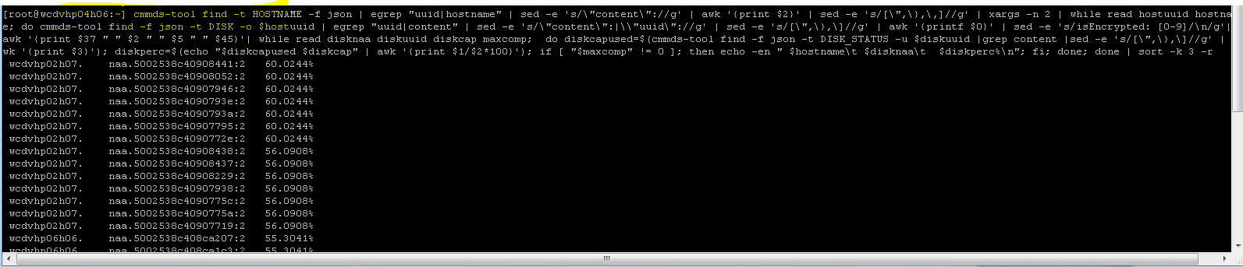

Command to get the UUID of the Hosts:

*cmmds-tool find -f json -t HOSTNAME |grep -E "uuid|content"|sed 'N;s/\n/ /'|awk -F \" '{print $10": " $4}'|sort*

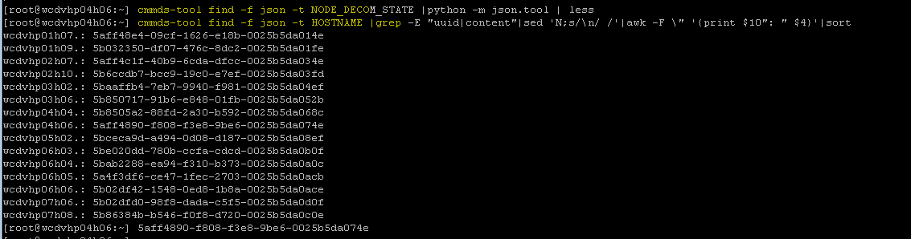

Command to get the Status of vSAN objects :

*cmmds-tool find -f python | grep CONFIG_STATUS -B 4 -A 6 | grep 'uuid\|content' | grep -o 'state\\\":\ [0-9]*' | sort | uniq -c*

{If value is 7 than all good.}

Command to get the vSAN Cluster :

*localcli vsan cluster get*

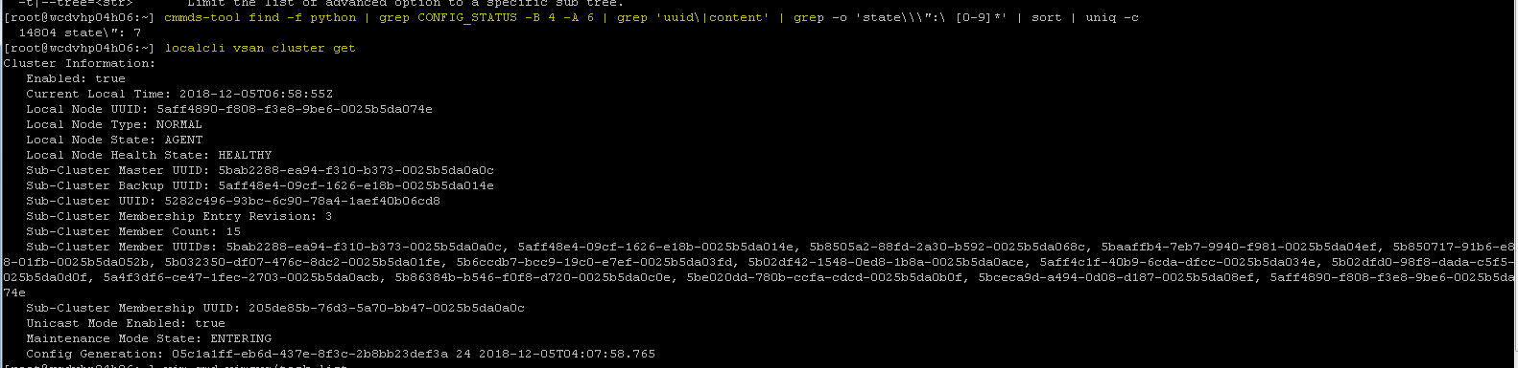

Command to check the disk availability Status(in below example there is no disk this is compute server)

*vdq -i*

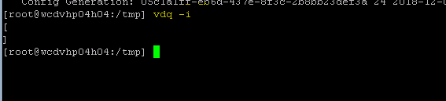

Command to get the default value of data sync:

*Vshish –e get /vmkModules/vsan/dom/MaxNumResyncCopyInFlight*

{In below output Value is set to 50 }



If you find performance issue with any VM, then you can reduce the value to 30 or 20 or minimum value to 1.

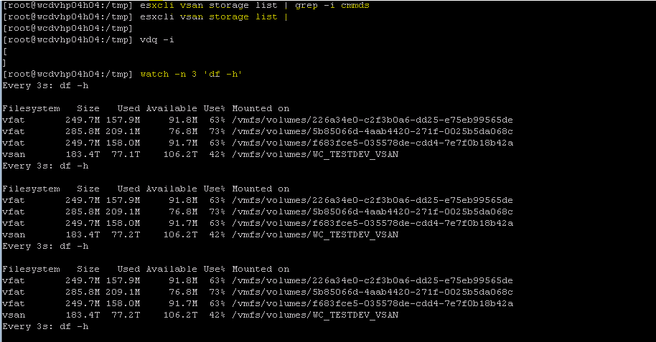

In vcenter ssh, go to RVC, check the status of the resync of vm disk.

